New St. James Presbyterian Church
A Congregation of the Presbyterian Church in Canada
“Following Christ, Worshipping God, Serving Others”
Sunday, December 28, 2025 at 10:30 a.m.

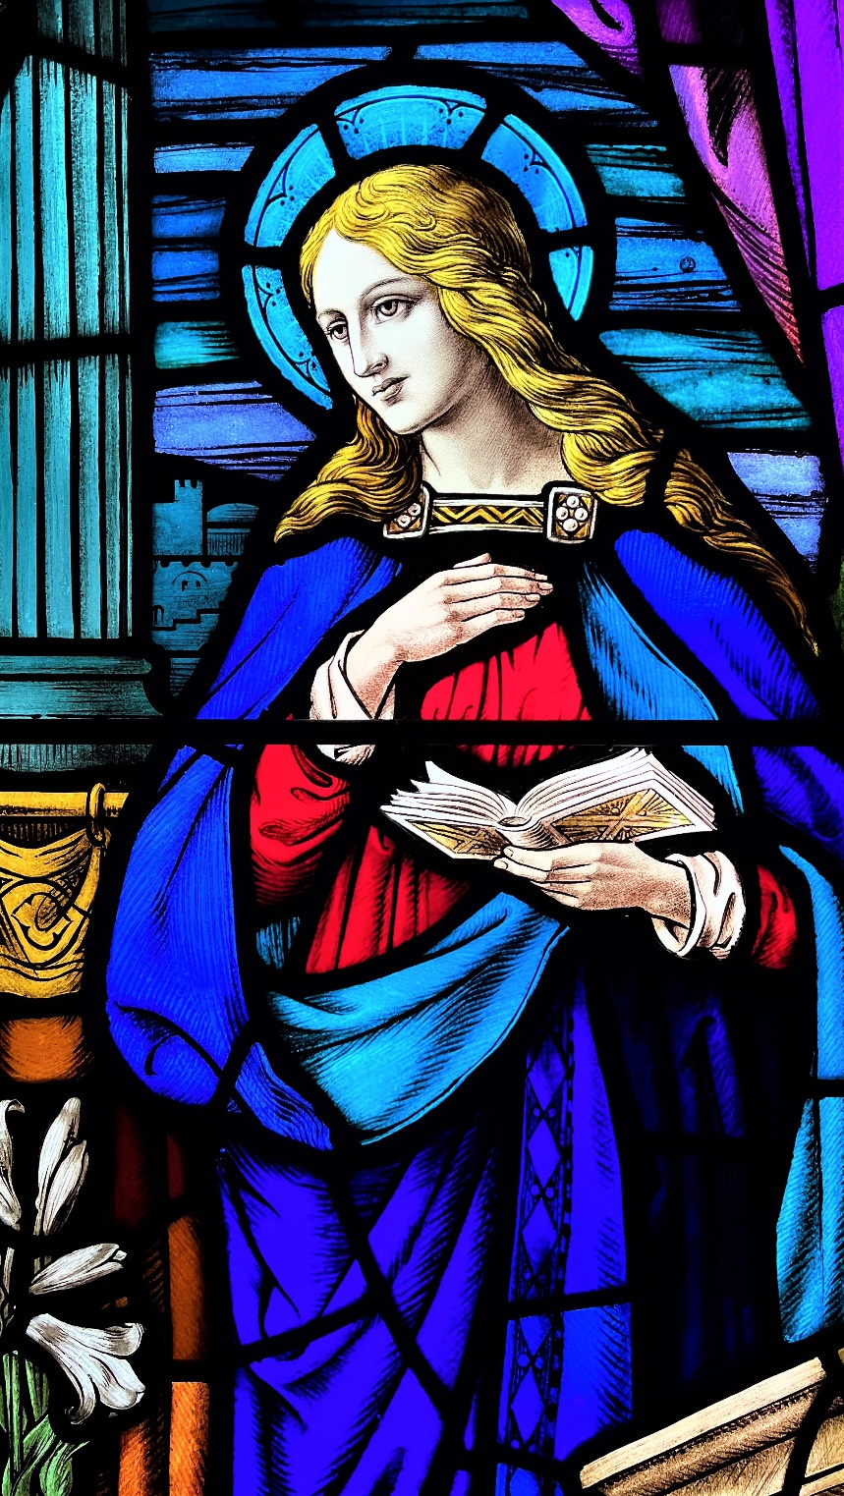
Detail from The Announcement to Mary (1933), New St. James

FIRST SUNDAY AFTER CHRISTMAS DAY

Minister: The Rev. Dr. David Clark
Director of Music: Torin W. Chiles
Reader: Mike Ruggi
Choristers: Janaki Butterworth, Ariel Harwood-Jones, Robert Hutson,
Angela Myshkowsky, and Anthony Rodrigues

We Gather to Worship God

Prelude I Wonder as I Wander arr. D. E. Thomas (2001)
* Processional Carol Lord, you were rich (FRAGRANCE) 134
* Responsive Call to Worship 1 John 4:9-10
God’s love was revealed among us in this way:
God sent his only Son into the world
so that we might live through him.
In this is love, not that we loved God
but that he loved us.
Prayers of Adoration and Confession
Word of Assurance for Christmastide (sung in unison) Titus 3:4-6 (RICHMOND) 118
The kindness of our God appears
to pour out richest grace;
as we are saved from sin and fears,
we see the Saviour’s face!
Welcome
We Hear the Word of God
We Hear the Word of God

* Children’s Carol O little town of Bethlehem (FOREST GREEN) 164
Word to the Children
Solo The Coventry Carol trad. English; arr. M. Hayes (1994)
Ariel Harwood-Jones, soprano
Lully, lullay, thou little tiny Child, by, by, luly, lullay; lullay, thou little tiny Child, by, by, lully, lullay. O sisters too, how may we do for to preserve this day, this poor Youngling for whom we do sing, by, by, lully, lullay? Herod the king, in his raging, charged he hath this day his men of might, in his own sight, all children young to slay. Then woe is me, poor Child for thee, and ever mourn and say, for thy parting nor say nor sing by, by, lully, lullay.
Prayer for Illumination (in unison)
Prepare our hearts, O God, to accept your Word. Silence in us any voice but your own, that, hearing, we may also obey your will; through Jesus Christ our Lord. Amen.
Old Testament Lesson Isaiah 63:7-9 p. 693 in N.T.
Responsive Psalm Psalm 148
Praise the Lord! Praise the Lord from the heavens; praise him in the heights!
Praise him, all his angels; praise him, all his host!
Praise him, sun and moon; praise him, all you shining stars!
Praise him, you highest heavens, and you waters above the heavens!
Let them praise the name of the Lord, for he commanded and they were created.
He established them forever and ever; he fixed their bounds, which cannot be passed.
Praise the Lord from the earth,
you sea monsters and all deeps, fire and hail, snow and frost, stormy wind fulfilling his command!
Mountains and all hills, fruit trees and all cedars!
Wild animals and all cattle, creeping things and flying birds!

Kings of the earth and all peoples, princes and all rulers of the earth!
Young men and women alike, old and young together!
Let them praise the name of the Lord, for his name alone is exalted;
his glory is above earth and heaven.
He has raised up a horn for his people,
praise for all his faithful, for the people of Israel who are close to him.
Praise the Lord!
* Gloria Patri
Glory be to the Father, and to the Son, and to the Holy Ghost,
as it was in the beginning, is now, and ever shall be, world without end. Amen.
Gospel Lesson Matthew 2:13-23 p. 2 in N.T.
Sermon “And Flee to Egypt” The Rev. Dr. David Clark
We Respond in Faith and Service

* Carol In Bethlehem a newborn boy (IN BETHLEHEM) 140
Offertory Infant Holy, Infant Lowly J. D. Peterson (2001)
* Doxology for Christmastide (WINCHESTER OLD) 138, verse 6
“All glory be to God on high,
and to the earth be peace;
good will henceforth from heaven to earth
begin, and never cease!”
* Prayer of Dedication
Announcements
Solo My Master Was So Very Poor D. Ouchterlony (1914-1987)
My Master was so very poor, a manger was His cradling place. So very rich my Master was, Kings came from far to gain His grace. My Master was so very poor, and with the poor He break the bread. So very rich my Master was, that multitudes by Him were fed. My Master was so very poor, they nailed Him to a cross. So very rich my Master was – He gave His all and knew no loss.
[text: Henry Lee (1874-1942)]
Prayers of Thanksgiving, Intercession, Commemoration,
and the Lord’s Prayer
Our Father in heaven, hallowed be your name,
your kingdom come, your will be done, on earth as in heaven.
Give us today our daily bread. Forgive us our sins as we forgive those who sin against us.
Save us from the time of trial and deliver us from evil.
For the kingdom, the power, and the glory are yours, now and forever. Amen.
* Recessional Carol I wonder as I wander (I wonder as I wander) 142
* Commission and Benediction
* Threefold Amen (DANISH) 780
Postlude Innocents F. Peeters (1903-1986)

Asterisk (*) indicates standing, as able.
Announcements
Welcome to today’s worship service. We are grateful that you have joined us! If you are worshipping here for the first time, please sign the Guest Book in the Narthex, located at the back of the Sanctuary. An Usher would be pleased to offer you directions.
Highland Group welcomes young children into the nursery, outside the west doors of the Sanctuary.
Please join us following worship for refreshments and fellowship in New St. James Hall.
Annual Report submissions are due to Nancy Manners no later than Thursday, January 15. This will allow the Annual Report to be compiled and distributed prior to the Annual Congregational Meeting to be held on Sunday, February 8. Thank you.
In December, your financial generosity is being doubled through matching gifts! Thanks to the generosity of anonymous donors, your financial gifts are automatically doubled. $16,500 has been committed: with matching gifts, this sets a goal of $33,000 for the life and ministry of New St. James.
There are now several options for you to provide regular financial support to New St. James:
- For Offering Envelopes, please call the Church Office (519.434.1127)
- Cheques may be mailed to NSJ: 280 Oxford St. E., London, ON N6A 1V4
- Pre-Authorized Remittance (PAR) it is a convenient way to give—and the church benefits from your steady contributions. Contributions are automatically debited from your bank account on the 20th of each month. To sign up for PAR, call the Church Office or visit www.newstjames.ca/donate-2
- To make an offering through e-transfer, please email Nancy Manners (Office Administrator) at admin@newstjames.ca
Income Tax statements are issued by New St. James each year by the end of February.
Thank you for supporting the life and mission of New St. James!
Announcements are an important way to keep the congregation informed about the ministry of NSJ. The weekly deadline for submitting a requested announcement is Wednesday at noon. Announcements are reserved for information regarding the ministry of New St. James and the Presbyterian Church in Canada.
A reminder to all NSJ groups and committees: please remember to book your meeting space in advance by contacting Nancy Manners in the Church Office.

Prayer for Illumination reprinted by permission from Book of Common Worship, © 1993 Westminster John Knox Press.
New St. James Presbyterian Church • 280 Oxford St. East • London, ON • N6A 1V4
519.434.1127 • www.newstjames.ca • admin@newstjames.ca

